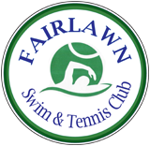

**Club Apparel Order Form**

**Name __________________________**

**Address_________________________**

**Phone___________________________**

*All Apparel available in White/Royal Blue/Forest Green. All apparel includes Fairlawn logo. Logo on pullover and polo is embroidered.

**Note: Please make check payable to: *RICHIE’S SPORTING GOODS.* Online ordering is NOT available-Please print order form and send to John Novak-1170 Lisa Ann Drive, Akron Ohio 44313 by June 15, 2014. (330-867-2677)**